Guidance for Topic 4 DQ 2
This one is just like Topic 3 DQ 1, just about loans instead of investments.
- As always, first enter your name.

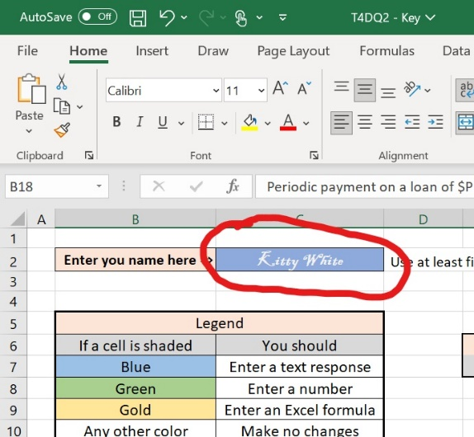

- You will get your personalized problem. Enter the parameters from your problem into the green cells P (loan amount/principal), r (APR), n (number of payments per year), and t (number of years to pay off the loan). Then, enter the correct formulas where indicated. As with Topic 3 DQ 1, this sheet will indicate if the numbers are correct and warn you if you have not used formulas where required.

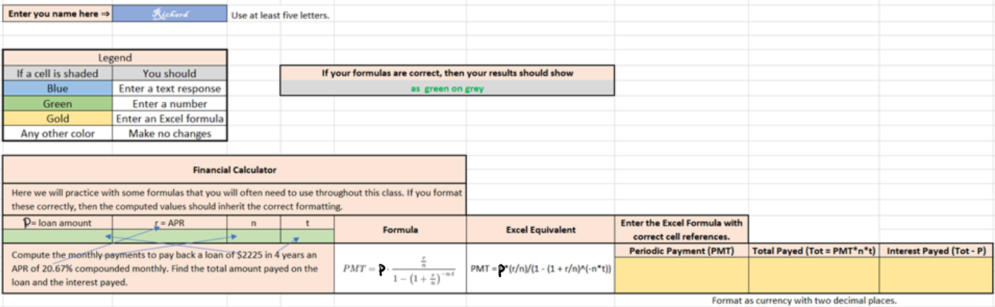

- For this DQ you must format the items correctly. The best thing to do is format the parameters (green cells) and then the formulas will inherit the correct formatting.

